Software: Types
sw_types.php — Software

Types of Software
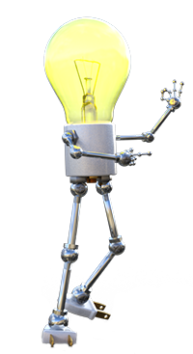

The THREE main categories of Software
Software can be categorised according to what job the software does.
Explore the three main categories of software in the panels below:
System Software
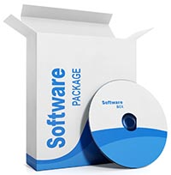
System Software is all the software that is used:
to control hardware
manage and maintain your computer
enable communication with networks
manage databases
allow you to develop software
Find out more details in the System Software module.
Back to the top of this Panel
Application Software
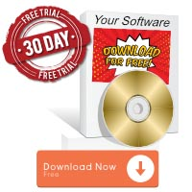
Application software is software that lets you (the user) get things done.
This software is what makes the computer a multi-purpose tool. Load one application and you are browsing the web. Load another and you are watching a video. Load another and you are designing a car or drawing a comic or playing a game or balancing a budget, or controlling a robot on Mars…
The possibilities are infinite!
Back to the top of this Panel
Embedded software
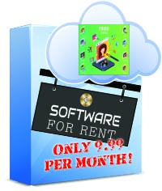
Software on embedded devices that tell the device what to do.
Examples include the instructions for your household appliances (microwave, fridge, washing machine, dishwasher, satellite TV decoder, etc.).
As more and more devices become 'smart' the demand for embedded software - and people who can create it - is increasing.
Back to the top of this Panel

